SharePoint Slider – Admin Guide

1. Solution Components:
   1. Site Assets Library, Slider Folder
   2. Promoted Links Library
   3. Slider Announcements Library
   4. Slider Web Part Page
   5. PAITSliderCEWP.js File
   6. Slider Workflow
   7. Custom Slider Announcements Display Page
   8. SliderDisplayPage.js
2. Site Assets Library \ Slider Folder
   1. URL: <https://bentest.bhcorp.ad/sites/regulatory3/testsite/SiteAssets/Forms/AllItems.aspx>
   2. Purpose: Provide an Archive for all Critical Solution Code Files
   3. Image Slider JavaScript Files:
      1. PAITSliderCEWP.js
      2. PAITSlider.js
      3. jquery-1.11.3.min.js
      4. unslider-min.js
   4. Image Slider CSS Files:
      1. unslider.css
      2. unslider-dots.css
3. Promoted Links Library
   1. URL: <https://bentest.bhcorp.ad/sites/regulatory3/testsite/Lists/PromotedLinks/AllItems.aspx>

* 1. Purpose: Provide a Means for Users to Link Images and Articles in the Slider
  2. Configuration: Promoted Links List Template with Custom Picture Content Type
  3. Custom Field: Body Field Customize for Enhanced Rich Text

* + 1. Open the Site and List from SharePoint Designer
    2. Click on the “Customization: Edit list columns” Link

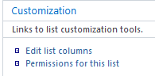

* + 1. From the Field Editor Interface Double Click on the Body Field

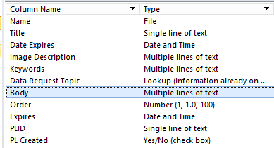

* + 1. From the Body Field Column Edit Interface Click on the Enhanced Rich Text Box and Then Click “OK”

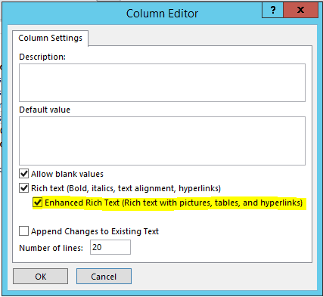

* + 1. Now Back at the Field Editor Interface Click on the Save Icon

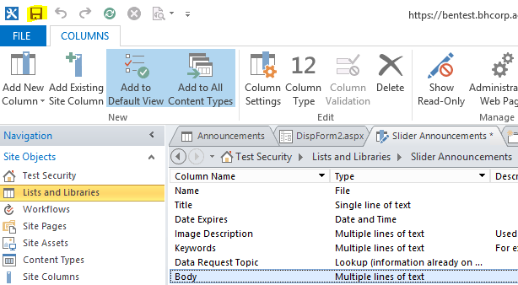

1. Slider Announcements Library
   1. URL: <https://bentest.bhcorp.ad/sites/regulatory3/testsite/Slider%20Announcements/>
   2. Purpose: Provides a Location for Creating Slider Announcements
   3. Configuration: Slider Announcements List Template
   4. Custom Field: Body Field Customize for Enhanced Rich Text
      1. Open the Site and List from SharePoint Designer
      2. Click on the “Customization: Edit list columns” Link



* + 1. From the Field Editor Interface Double Click on the Body Field



* + 1. From the Body Field Column Edit Interface Click on the Enhanced Rich Text Box and Then Click “OK”



* + 1. Now Back at the Field Editor Interface Click on the Save Icon



1. Slider Web Part Page
   1. URL: <https://bentest.bhcorp.ad/sites/regulatory3/testsite/Pages/Slider.aspx>
   2. Purpose: Provides a Display Surface for the Slider Solution
   3. Configuration:
      1. Create a Web Part Page
      2. Add a Content Editor Web Part to the Web Part Page
      3. Configure the Content editor Web Part to Point to the PAITSliderCEWP.js File in the Assets Library
2. PAITSliderCEWP.js File
   1. Purpose: Provides Configuration for the Slider Look, Feel, and Function
   2. Configuration:
      1. .PAITSlide (CSS Class)
         1. Purpose: Configure the Appearance of the Image
         2. Configuration:
            1. height: 240px; // The Height of the Image
            2. width: 400px; // The Width of the Image
            3. margin: auto; // The Margin Around the Image
            4. border: 3px solid #FFA500; // The Border Width of the Margin Around the Image
      2. .unslider-nav ol li (CSS Class)
         1. Purpose: Style the Slider “Dots” (Navigation Aids Below the Image)
         2. Configuration:
            1. border: 2px solid #FFA500; // The Color and Width of the Border Around the Dots
            2. border-radius: 50%; // The Border Radius (50% Makes the Dots Round)
      3. .unslider-nav ol li.unslider-active (CSS Class)
         1. Purpose: Style the Background of the Dots
         2. Configuration:
            1. background: #FFA500; // The Background (Fill) of the Dots
      4. .unslider-arrow (CSS Class)
         1. Purpose: Styling for the Slider Arrow
         2. Configuration: Not Used
      5. .next, .prev (CSS Class)
         1. Purpose: Configure the Left/Right Arrow
         2. Configuration: Not Used
      6. PAITSlider (JavaScript)
         1. Purpose: Configure the Function of the Slider
         2. Configurations:
            1. listName: The name of the Promoted Links list where the posts are located
            2. viewTitle: Name of the View in the Promoted Links to Use
            3. prev: HTML for the Previous Arrow
            4. next: HTML for the Next Arrow
            5. autoplay: Will the Slider Autoplay // Select True/False
            6. infinite: Will the Slider Autoplay Infinitely // Select True/False
            7. animation: Animation Flow // Select Horizontal or Vertical
            8. arrows: Show the Arrows // Select True/False
            9. dots: Show the Dots // Select True/False
            10. keys: Not Used
            11. delay: Delay Between Image Displays – Measured in Milliseconds
3. Slider Workflow
   1. Purpose: When a New Article is Created, the Nintex Slider Workflow Copies the Attached File to the Image Library, and Creates a New Promoted Links Item.
   2. Configuration:
      1. Set a Condition:

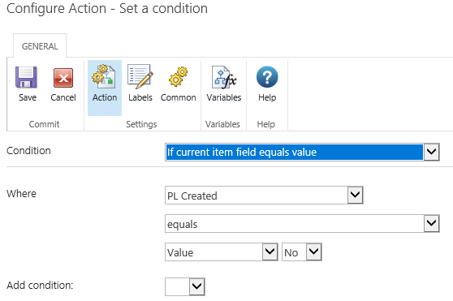

ii. No, Log in History List:

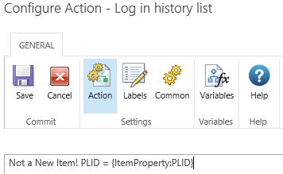

iii. No, Update Item:

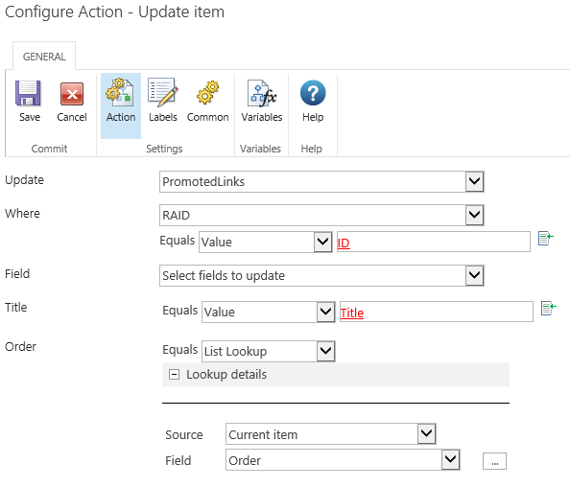

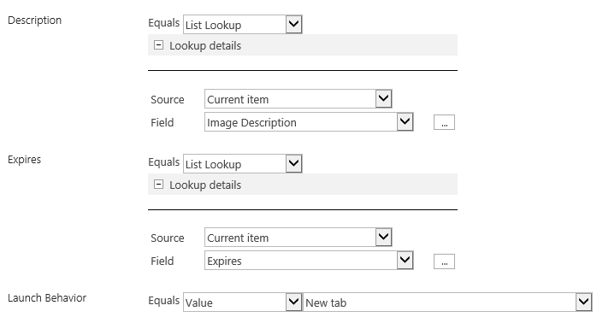



iv. No, Log in History List:

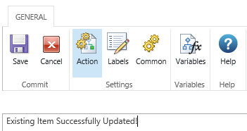

v. Yes, Log in History Log:

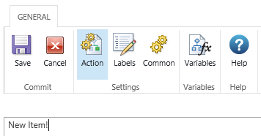

vi. Yes, Create Item

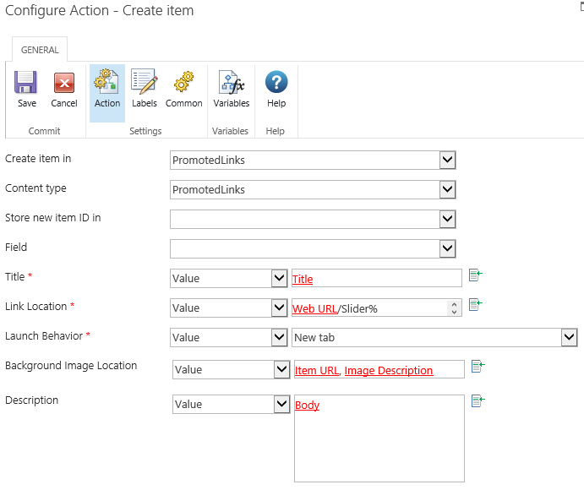

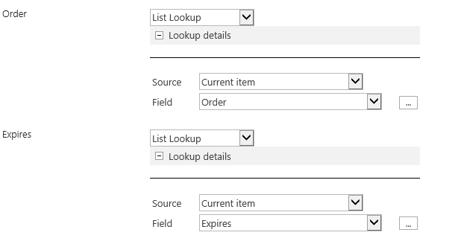

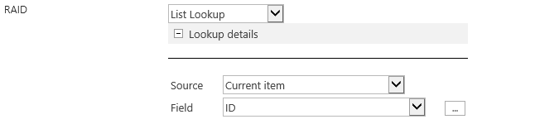

vii. Yes, Update Item:

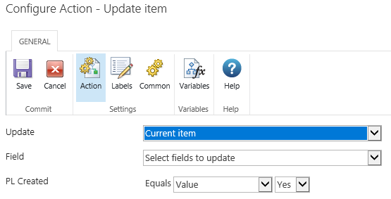

viii. Yes, Log in History Log:

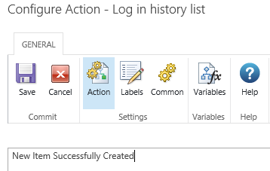

1. Custom Slider Announcements Display Page:
   1. Purpose: When Article is Displayed, the Custom Slider Announcements Display Page Presents the Data Without the Normal Form Field Elements.
   2. Configuration:
      1. Navigate to the Display Form by Clicking on a Slider Image
      2. Add a Content Editor Web Part to the Display Form
      3. Open the Content Editor Web Part in the Edit Mode
      4. Insert or Link to the Code from the SliderDisplayPage.js Page
      5. From the Web Part Editing Pane Click “OK”
      6. From the Page Ribbon Click “Stop Editing”
      7. The Custom Slider Announcements Display Page will now be Updated with the New Code
2. SliderDisplayPage.js File:
   1. Purpose: The SliderDisplayPage.js File is Used in Conjunction with the Custom Slider Announcements Display Page to Remove Field Values and Labels and Hide the Quick Launch Bar.
   2. Configuration – jQuery:
      1. Hide the Title Field: $(".ms-standardheader:contains('Title')").closest("tr").hide();
      2. Hide the Order Field: $(".ms-standardheader:contains('Order')").closest("tr").hide();
      3. Hide the Expires Field: $(".ms-standardheader:contains('Expires')").closest("tr").hide();
      4. Hide the Image Description Field: $(".ms-standardheader:contains('Image Description')").closest("tr").hide();
      5. Hide the PL Created Field: $(".ms-standardheader:contains('PL Created')").closest("tr").hide();
      6. Hide the PData Request Topic Field: $(".ms-standardheader:contains('PData Request Topic')").closest("tr").hide();
      7. Hide the Data Request Topic Field: $(".ms-standardheader:contains('Data Request Topic')").closest("tr").hide();
      8. Hide the Body Field: $(".ms-standardheader:contains('Body')").closest("td").hide();
   3. Configuration – CSS:
      1. Hide the Quick Launch:

#sideNavBox {DISPLAY: none}

#contentBox {MARGIN-LEFT: 5px}

* + 1. Hide the Toolbar:

.ms-formtoolbar{ display: none !important; }

* + 1. Hide the Close Button:

$("input[value='Close']").hide();